

**Dear parents and carers,**

It’s been another busy week here at The Grove School, we have taken our first trip out of the year, to see an exciting Champions League Game at the Etihad Stadium. We also have had our first sporting fixtures - congratulations to our Year 7 girls football team who won the competition! On site, we have installed more benches and have hosted several visits from members of the local community.

However, we also received some devastating news as a team as one of our Year 7 students sadly lost his courageous battle with cancer. As you can imagine this is an incredibly difficult time, but the school community has pulled together brilliantly, and we continue to send all of our love and wishes to the family. If your children have been affected by the loss, please have a look at some of the links below, or on the letter that I sent to families on Thursday.

Wishing you all a fantastic weekend,

Mr Mitchell Allsopp

**Headteacher**

**Friday 20th September 2024**

**REMINDERS & NOTICES**

**Flying High**

Last week we told you about Isabelle Gledhill and her flying challenge. Well, we are pleased to announce that Isabelle completed her flight over all of the Marches Trust Schools and has raised an amazing amount for the Hope House Charity. What an amazing achievement. Well done!

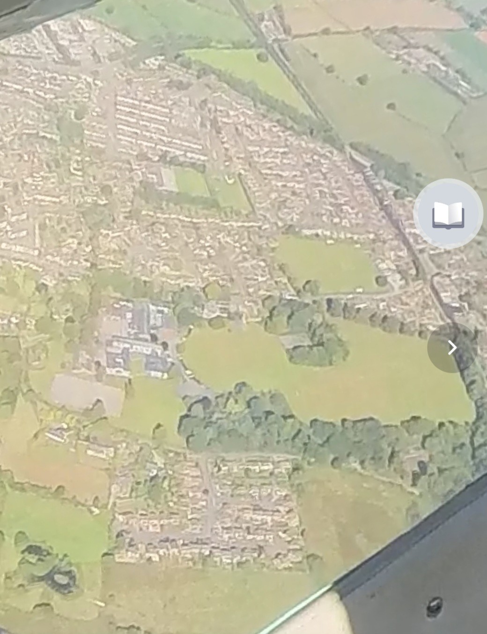

**Dodgeball**

On Wednesday, our Year 7s took part in a dodgeball event, organised by some of our Sixth Form students. The atmosphere was electric as students showcased their agility and teamwork. The highlight of the day was Mr. Jones’s form clinching the victory, much to the delight of their classmates. Everyone had a 'ball', making it a memorable event for all involved.

**One Man and his Dog!**

Team Grove received a fantastic array of items from AR Richards Skip Hire and Waste Management, this week. The items donated included magnifying glasses, compasses, Javelins, tennis nets, microscopes and various other pieces of educational equipment. Making sure the donation boxes reached us safely, was Ben the Dog. He was very well behaved and stayed still long enough to get his picture taken with Mr Allsopp. All staff and students will greatly appreciate this amazing donation and it will be of benefit to the whole school. We are very grateful!

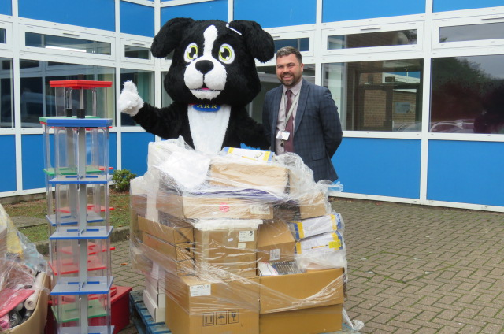

.

**Yr 5 & 6 Open Evening**

We have our first Open Evening of the year, on Tuesday 24th September from 4.30pm. This event is for local primary school age children to come along and experience life here at Team Grove. There will also be an opportunity for parent and carers to meet our staff and ask questions. Mr Allsopp will be holding a talk at 5pm & 6pm during the evening. If you have any friends or family currently in Year 5 and Year 6 then please invite them along. We love showing off our fabulous school!

**Manchester City v Inter Milan**

The Year 11 trip to the Manchester City versus Inter Milan Champions League match on Wednesday 18th September, was an unforgettable experience! Twenty-five students had the chance to watch their football heroes in action. Despite the match ending without a goal, the students had a memorable time. As always, they represented Team Grove admirably, soaking in the atmosphere and enjoying the experience of visiting an iconic ground. We have lots of other wonderful trips taking place over the term, so keep looking out for the information via email!

**Grief Support**

Following our challenging week, if you or your family are struggling at this time, we would like to remind you that we at Team Grove are here to help. Please reach out to us if needed. Additionally, resources such as [Child Bereavement UK](https://www.childbereavementuk.org/), [When someone in the school community dies](https://www.childbereavementuk.org/managing-grief-at-school), and [Winston’s Wish](https://winstonswish.org/supporting-you/?gad_source=1&gclid=Cj0KCQjw9Km3BhDjARIsAGUb4nz2YGdrchnRMajc0W8I21pMdR0VZlCTVBA00ElhdMuknhsYNUSM8sEaAn-tEALw_wcB) may be helpful.



**To sign up please go and see**

**Downhill Mountain Bike Star**

Over the summer Charlie Toomer, in Year 10, excelled on his downhill mountain bike. Two national wins and two podiums helped him win the ‘U15’s British Downhill’ overall series after the last round in Wales. This means that Charlie will finish the year as the top ranked in the UK for his age! Over the holidays he travelled to Champery, Switzerland for the European Championships where he finished 7th, and he also became ‘U15’s National Champion’ in July at Rhyd Y Fellin near Bala.

Well done, Charlie. Everyone at Team Grove is proud of you!

**UPCOMING EVENTS**

24 Sept Yr 6 Open Evening 4.30-7.30pm

3 Oct Yr 11 Geography Fieldtrip to

Llandudno

10 Oct Sixth Form Open Evening 4.30-7.30pm

15Oct Alton Towers Rewards Trip- Y7-11

16 Oct Lion King Rewards Trip - Y8 and Y9

17 Oct Hamilton Rewards Trip – Y10-13

18 Oct PD Day- No students in school

21 Oct Half Term

4 Nov School Opens

20 Dec Last Day of Term

**NEWS**

Click: [Home - Grove School and Sixth Form (groveschoolmarketdrayton.co.uk)](https://groveschoolmarketdrayton.co.uk/) to view our latest news articles.

Why not also follow us on Facebook @[GroveSchoolShropshire](https://www.facebook.com/GroveSchoolShropshire/) for a wealth of content, from student, staff and school celebrations, to competitions. We encourage you to get interactive with our posts.

To hear about news from across the Trust, why not also follow @[MarchesAcademyTrust.](https://www.facebook.com/MarchesAcademyTrust/)

**| Grove School & Sixth Form, Newcastle Road, Market Drayton, TF9 1HF**

**| 01630 652121**

**| admin@gro.mmat.co.uk**

**| groveschoolmarketdrayton.co.uk**

**@GroveSchoolShropshire**

